**User managemet --- task -1**

1. **Adding group csk rcb**

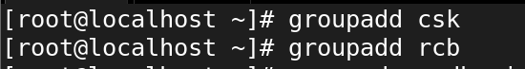

1. **Creating user dhoni,raina Virat faf**

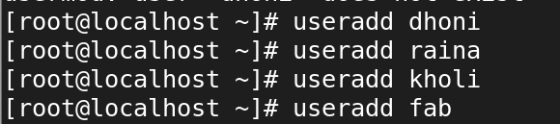

1. **Adding users Dhoni raina to csk**

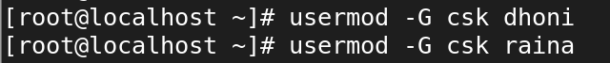

1. **Adding users virat faf to rcb**

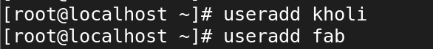

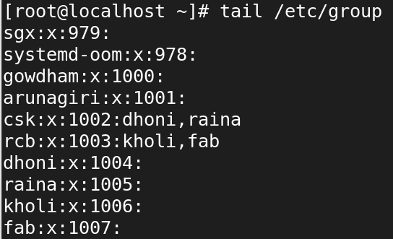

1. **Creating dir cricket in /**

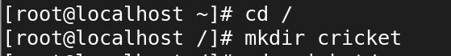

1. **Creating dir kings challengers inside the cricket directory**



1. **Change full permission for other to cricket directory and for sub directories change group as CSK for kings and change group as RCB for challengers**

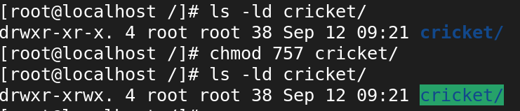

1. **Now give Full permission for the group to kings directory and also give same for challengers directory**

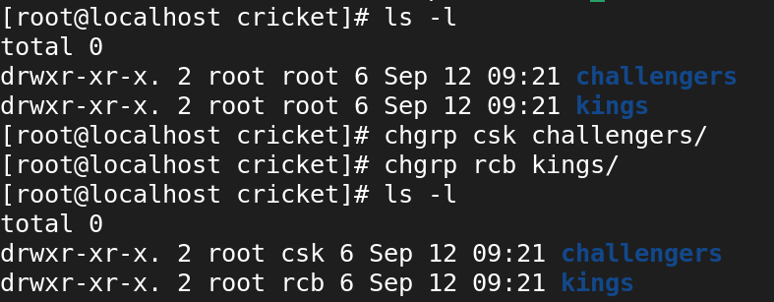

1. **Remove all permission for others from both the kings and challengers directory**

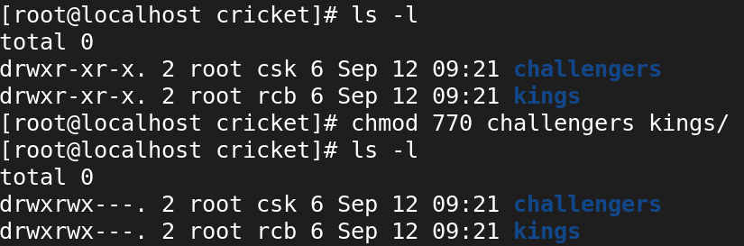

Su--> user from csk group member and try to change directory in other group dir

